FIFTH GRADE Kit Contents
Item | Quantity
Sticky Notes - 3"x3", yellow, 1pk/100 ct | 3
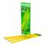 Pencils - Ticonderoga, #2, pre-sharpened, 12 ct | 4
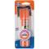 Glue Sticks - Elmer's, small, purple disappearing, 0.21 oz | 1
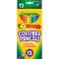 Colored Pencils - Crayola, 12 ct | 1
Pens - Paper Mate, flair, black, 1 ct | 1
Pens - flair, blue, 1 ct | 1
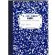 Notebook - composition, wide ruled, 9.75"x7.5", blue, 100 ct | 1
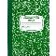 Notebook - composition, wide ruled, 9.75"x7.5", green, 100 ct | 1
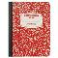 Notebook - composition, wide ruled, 9.75"x7.5", red, 100 ct | 1
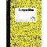 Notebook - composition, wide ruled, 9.75"x7.5", yellow, 100 ct | 1
Folder - 2 pocket, 3 hole, blue | 2
Folder - 2 pocket, 3 hole, green | 2
Folder - 2 pocket, 3 hole, red | 2
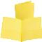 Folder - 2 pocket, 3 hole, yellow | 2
Folder - 2 pocket, 3 hole, black | 2
Eraser - rectangular, medium, pink, 1 ct | 2
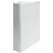 Binder - 1.5", 3-ring, clear view, w/ inside pockets, white | 1
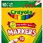 Markers - Crayola, classic, broad, 10 ct | 1
Highlighter - yellow, 1 ct | 1

