FIRST GRADE SUPPLIES

Item | Quantity
Folder - 2 pocket, 3 prong, red | 1
Folder - 2 pocket, 3 prong, yellow | 1
Folder - 2 pocket, 3 prong, blue | 1
Folder - 2 pocket, 3 prong, green | 1
Folder - 2 pocket, 3 prong, orange | 1
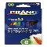 Markers - Dixon Ticonderoga Prang, classic, washable, fine, 8 ct | 1
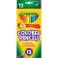 Colored Pencils - Crayola, 12 ct | 1
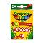 Crayons - Crayola, 24 ct | 1
Pens - Paper Mate, flair, black, 1 ct | 10
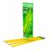 Pencils - Ticonderoga, #2, pre-sharpened, 12 ct | 1
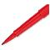 Pens - flair, red, 1 ct | 2
Pens - flair, blue, 1 ct | 2
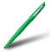 Pens - Paper Mate, flair, green, 1 ct | 2
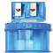 Pencil Sharpener - 2-hole with paper catcher, 1 ct | 1
Eraser - rectangular, medium, pink, 1 ct | 1
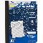 Notebook - Mead primary composition, full page ruled, 9.75"x7.5", 100 ct | 2
Marker - Expo, dry erase, fine tip, black, 1 ct | 5
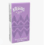 Tissue - Kleenex, 10 ct | 1
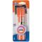 Glue Sticks - Elmer's, small, purple disappearing, 0.21 oz | 2
Sticky Notes - 3"x3", asst colors, 1 pk/100 ct | 2
Tape - 3/4" transparent w/dispenser, 1 ct | 2
Scissors - premium 5", blunt tip, 1 pair | 1
Watercolor Paints - Crayola with brush, 8 ct | 1

