FOURTH GRADE Kit Contents
Item | Quantity
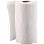 Paper Towels - 1 roll | 1
Tissues - Kleenex, 144 ct | 1
Sticky Notes - 3"x3", asst colors, 1 pk/100 ct | 1
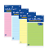 Sticky Notes - 4"x6", lined, 50 ct | 1
Paper - loose leaf, wide ruled, 100 ct | 1
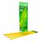 Pencils - Ticonderoga, #2, pre-sharpened, 12 ct | 2
Glue Sticks - Elmer's, small, purple disappearing, 0.21 oz | 2
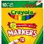 Markers - Crayola, classic, broad, 10 ct | 1
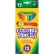 Colored Pencils - Crayola, 12 ct | 1
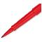 Pens - flair, red, 1 ct | 1
Pens - flair, blue, 1 ct | 1
Pens - Paper Mate, flair, black, 1 ct | 1
Pens - Paper Mate, flair, green, 1 ct | 1
Pens - Paper Mate, flair, black, 1 ct | 4
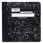 Notebook - Mead, composition, wide ruled, 9.75"x7.5", 100 ct | 5
Folder - plastic, 2 pocket, 3 holes, white | 1
Folder - plastic, 2 pocket, 3 hole, green | 1
Folder - plastic, 2 pocket, 3 hole, black | 1
Folder - plastic, 2 pocket, 3 hole, blue | 1
Folder - plastic, 2 pocket, 3 hole, yellow | 1

