Item | Quantity
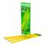 Pencils - Ticonderoga, #2, pre-sharpened, 12 ct | 2
Pens - Paper Mate, flair, black, 1 ct | 8
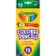 Colored Pencils - Crayola, 12 ct | 1
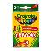 Crayons - Crayola, 24 ct | 1
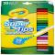 Markers - Crayola, Super Tips, 20 ct | 1
Eraser - rectangular, medium, pink, 1 ct | 1
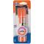 Glue Sticks - Elmer's, small, purple disappearing, 0.21 oz | 3
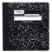 Notebook - Mead, composition, wide ruled, 9.75"x7.5", 100 ct | 2
Sticky Notes - 3"x3", yellow, 1pk/100 ct | 3
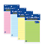 Sticky Notes - 4"x6", lined, 50 ct | 1
Folder - 2 pocket, 3 prong, yellow | 1
Folder - 2 pocket, 3 prong, blue | 1
Folder - 2 pocket, 3 prong, red | 1
Folder - 2 pocket, 3 hole, orange | 1
Folder - 2 pocket, 3 hole, green | 1
Folder - 2 pocket, 3 hole, purple | 1
Marker - Expo, dry erase, fine tip, black, 1 ct | 4
Watercolor Paints - Crayola with brush, 8 ct | 1

