THIRD GRADE Kit Contents
Item | Quantity
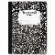 Notebook - composition, wide ruled, 9.75"x7.5", black, 100 ct | 3
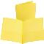 Folder - 2 pocket, 3 hole, yellow | 1
Folder - 2 pocket, 3 hole, orange | 1
Folder - 2 pocket, 3 hole, blue | 1
Folder - 2 pocket, 3 hole, green | 1
Folder - 2 pocket, 3 hole, red | 1
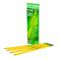 Pencils - Ticonderoga, #2, pre-sharpened, 12 ct | 3
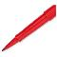 Pens - flair, red, 1 ct | 1
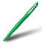 Pens - Paper Mate, flair, green, 1 ct | 1
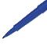 Pens - flair, blue, 1 ct | 1
Pens - Paper Mate, flair, black, 1 ct | 1
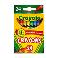 Crayons - Crayola, 24 ct | 1
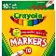 Markers - Crayola, classic, broad, 10 ct | 1
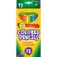 Colored Pencils - Crayola, 12 ct | 1
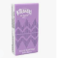 Tissue - Kleenex, 10 ct | 1
Sticky Notes - 3"x5", asst colors, 1 pk/70 ct | 1
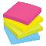 Sticky Notes - 3"x3", asst colors, 1 pk/100 ct | 1
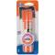 Glue Sticks - Elmer's, small, purple disappearing, 0.21 oz | 2
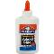 Glue - Elmer's School Glue, 4 oz | 1
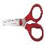 Scissors - premium 5", blunt tip, 1 pair | 1
Tape - 3/4" transparent w/dispenser, 1 ct | 1
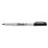 Marker - Sharpie, fine tip, black, 1 ct | 2
Watercolor Paints - Crayola with brush, 8 ct | 1
Eraser - rectangular, medium, pink, 1 ct | 1

